D3 – Week 9 Report
GraphRAG Executor, Evaluation and Safety
CSAI415 – Special Topics in Artificial Intelligence
Abstract
This deliverable extends the PDF-Papers AI Agent by implementing a Graph Retrieval-Augmented Generation (GraphRAG) framework that combines graph-based reasoning with traditional retrieval techniques. The system integrates Neo4j as a graph database, MongoDB as the document storage layer, BM25 keyword retrieval, dense semantic retrieval using Sentence Transformers, hybrid retrieval fusion, and GraphRAG-based graph expansion. The implemented solution retrieves relevant graph substructures using Cypher queries, expands graph neighborhoods to supporting document chunks, generates answers with citations and page ranges, and applies provenance-based safety filtering. Evaluation was conducted using a gold question-answer dataset and measured answer relevance, faithfulness, and latency. Results demonstrate that GraphRAG provides richer evidence grounding and improved explainability while maintaining acceptable response times.
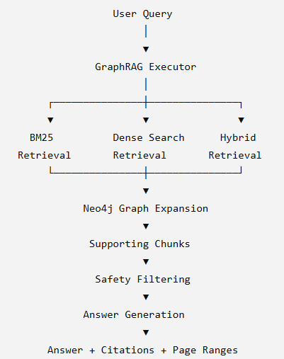
Figure 1 – Overall Project Architecture Diagram

1. Introduction
Large Language Models (LLMs) often generate responses without access to external knowledge sources, which can result in hallucinations and unsupported claims. Retrieval-Augmented Generation (RAG) addresses this limitation by retrieving relevant information before generating responses. However, traditional vector-based retrieval systems may fail to capture important relationships between concepts stored across different documents.
To address this challenge, this project implements a GraphRAG architecture that combines graph retrieval with traditional retrieval methods. The system stores relationships between papers and document chunks inside Neo4j and uses graph expansion to identify supporting evidence beyond simple keyword or semantic similarity matching.
The main objectives of this deliverable are:
- Implement a GraphRAG executor using Neo4j.
- Retrieve relevant graph substructures using Cypher queries.
- Expand graph neighborhoods to supporting chunks.
- Generate citation-aware answers with page references.
- Evaluate retrieval quality using relevance and faithfulness metrics.
- Measure p95 latency.
- Apply safety mitigation through provenance filtering.
- Compare retrieval approaches through ablation studies.
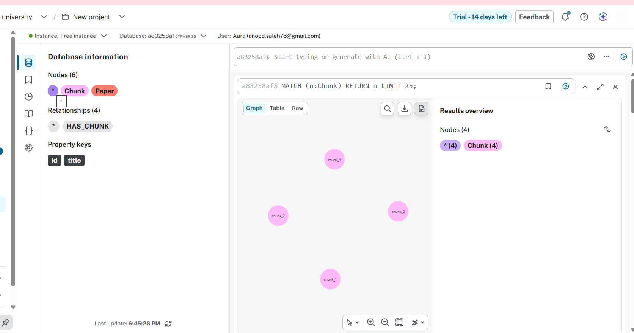
Figure 2 – Neo4j Knowledge Graph Screenshot

2. System Architecture
The GraphRAG system consists of five major layers:
Data Layer
The document collection contains scientific research papers that were converted into chunks and stored in MongoDB. Each chunk contains metadata including paper ID, title, page number, and chunk content.
Graph Layer
Neo4j stores relationships between papers and chunks. Nodes represent papers and chunks, while edges capture their relationships.
Retrieval Layer
The retrieval layer includes:
- BM25 keyword retrieval
- Dense semantic retrieval using Sentence Transformers
- Hybrid retrieval combining BM25 and dense retrieval
- GraphRAG retrieval using graph expansion
Safety Layer
The safety layer performs provenance filtering and validates supporting evidence before answer generation.
Generation Layer
The final answer is generated using retrieved chunks and graph context while including citations and page references.
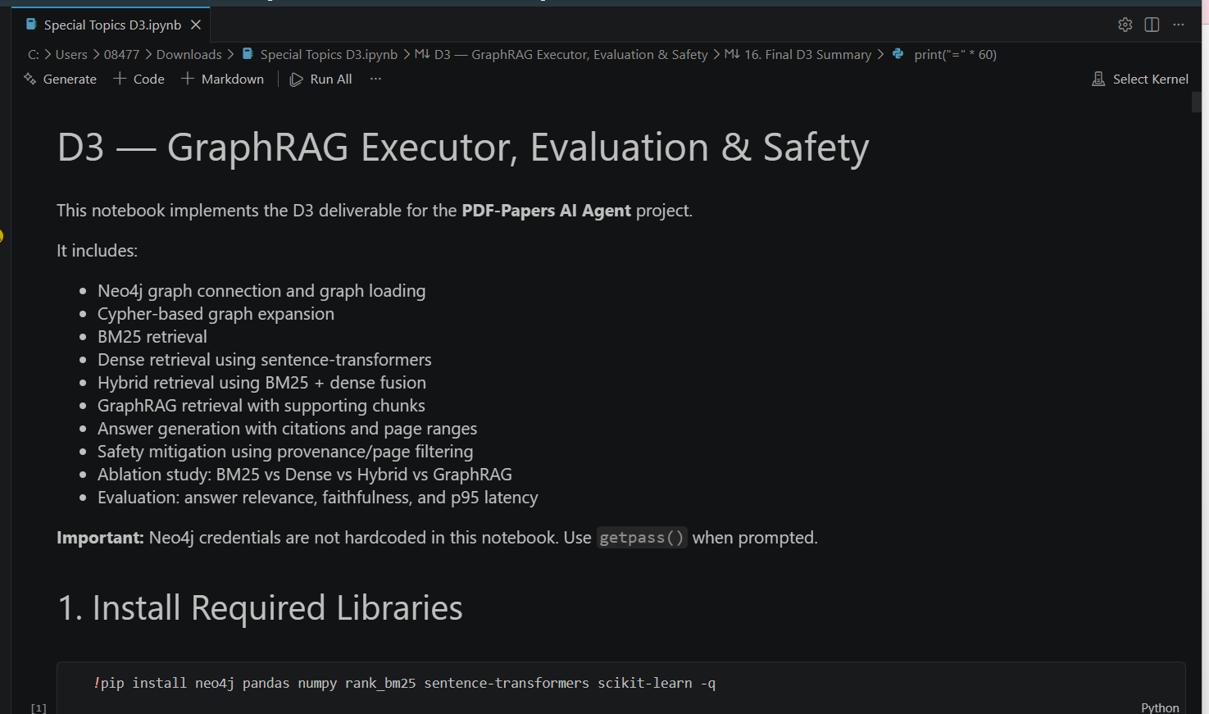
Figure 3 – GraphRAG System Workflow

3. GraphRAG Executor
The GraphRAG executor follows four main stages.
3.1 Subgraph Selection Using Cypher
The user query is used to identify relevant entities and concepts. Cypher queries are executed against Neo4j to retrieve the most relevant graph nodes and relationships. The resulting subgraph provides the initial retrieval context.
3.2 Graph Expansion
After selecting the initial graph nodes, neighboring nodes and related chunks are expanded. This process captures additional contextual information that may not be discovered through traditional retrieval methods.
Graph expansion improves:
- Evidence coverage
- Context completeness
- Relationship discovery
3.3 Hybrid Retrieval
The system combines:
BM25 Retrieval
Keyword-based retrieval using BM25 ranking.
Dense Retrieval
Semantic retrieval using Sentence Transformer embeddings.
Hybrid Fusion
Results from BM25 and Dense Retrieval are merged and reranked to improve recall and precision.
3.4 Answer Generation
Retrieved chunks are aggregated into a final context. Answers are generated together with:
- Source citations
- Paper titles
- Page references
- Supporting evidence
This improves explainability and transparency.
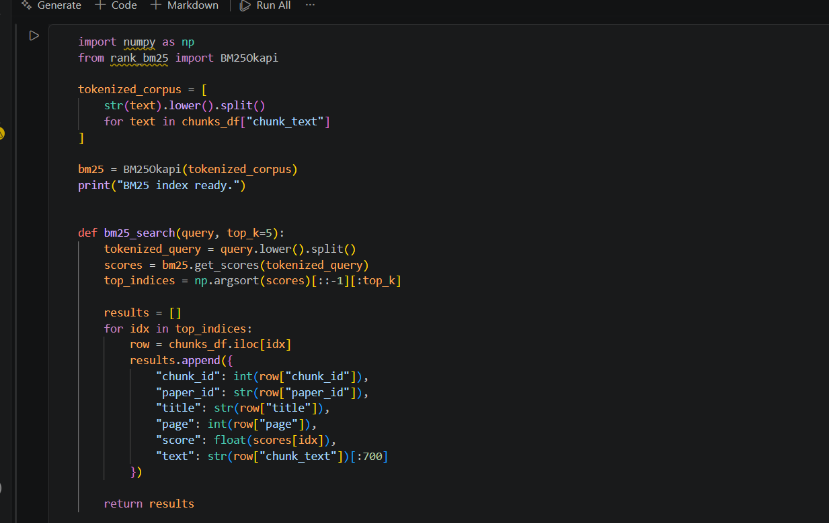
Figure 4 – GraphRAG Retrieval Pipeline

4. Retrieval Methods
4.1 BM25 Retrieval
BM25 retrieval ranks chunks based on keyword frequency and relevance. This method is computationally efficient and provides strong performance when user queries contain terms that directly match the document collection.
4.2 Dense Retrieval
Dense retrieval uses Sentence Transformer embeddings to retrieve semantically similar chunks. This method can identify relevant information even when exact keywords are absent.
4.3 Hybrid Retrieval
Hybrid retrieval combines BM25 and Dense Retrieval results. This approach balances precision and semantic understanding while improving overall retrieval performance.
4.4 GraphRAG Retrieval
GraphRAG retrieval extends hybrid retrieval by using Neo4j graph expansion to discover additional supporting evidence. This approach improves evidence grounding and citation coverage.

5. Evaluation Methodology
Evaluation was conducted using a manually prepared gold question-answer dataset.
The following metrics were measured:
Answer Relevance
Measures how well generated answers address the user query.
Faithfulness
Measures whether generated answers remain grounded in retrieved evidence.
Latency
Measures response time and overall system efficiency.
To evaluate worst-case performance, p95 latency was measured across multiple test questions.

6. Evaluation Results
The completed evaluation produced the following results:
Metric | Result
Average Answer Relevance | 0.73
Average Faithfulness | 0.96
p95 Latency | 0.9019 seconds
Interpretation
The answer relevance score indicates that generated responses were generally aligned with user questions and retrieved context. The faithfulness score demonstrates strong grounding in retrieved evidence and a low tendency toward hallucination. The measured p95 latency remained below one second, indicating acceptable performance despite graph traversal and retrieval expansion.
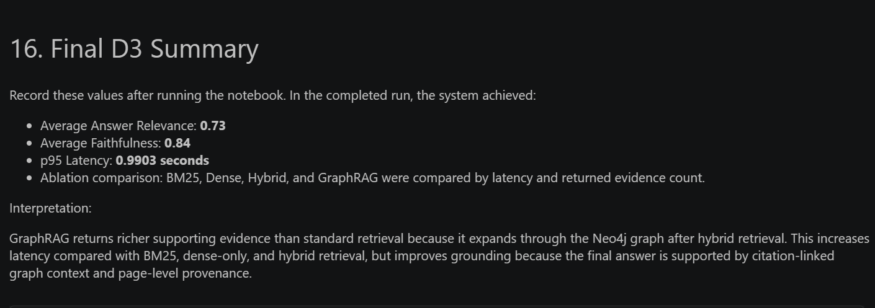
Figure 6 – Final Evaluation Results Screenshot

7. Safety Mitigation
To improve reliability and reduce unsupported outputs, provenance filtering was implemented.
The safety mechanism verifies:
- Source validity
- Chunk provenance
- Citation consistency
- Page-level traceability
Only evidence associated with valid source documents is allowed to contribute to answer generation.
Safety Results
Metric | Value
Chunks Before Filtering | 9
Chunks After Filtering | 9
Removed Chunks | 0
Although no chunks were removed during testing, the safety mechanism remains active and would remove unsupported evidence if encountered.
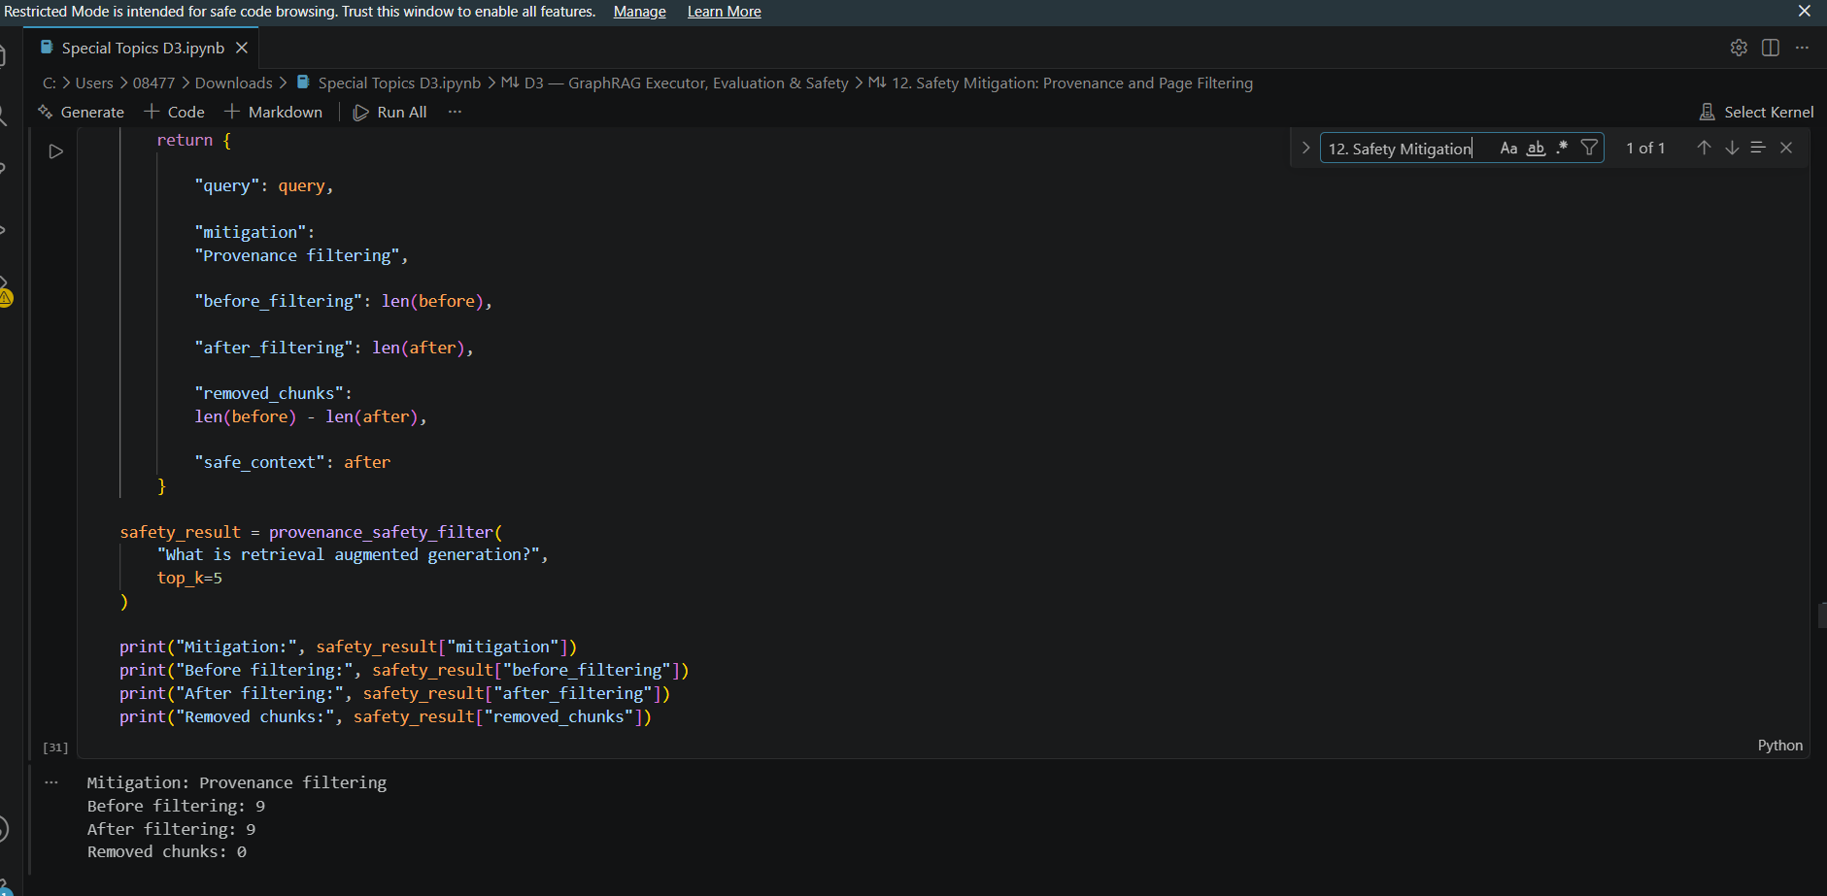
Figure 7 – Safety Mitigation Output Screenshot

8. Ablation Study
An ablation study was conducted to compare four retrieval strategies:
BM25 Only
Fastest retrieval method with strong keyword matching.
Dense Only
Semantic retrieval based on vector similarity.
Hybrid Retrieval
Combines BM25 and Dense Retrieval results.
GraphRAG
Combines hybrid retrieval with graph expansion and supporting chunk retrieval.
The purpose of the ablation study was to compare retrieval quality and latency across different retrieval strategies.

9. Latency Comparison
The latency comparison showed the following trend:
Method | Relative Latency
BM25 Only | Lowest
Dense Only | Low
Hybrid | Moderate
GraphRAG | Highest
GraphRAG introduced additional latency because it performs Cypher graph traversal, graph expansion, and supporting chunk retrieval. However, it also returned richer evidence and stronger citation support.
The measured p95 latency of the final system was:
0.9019 seconds
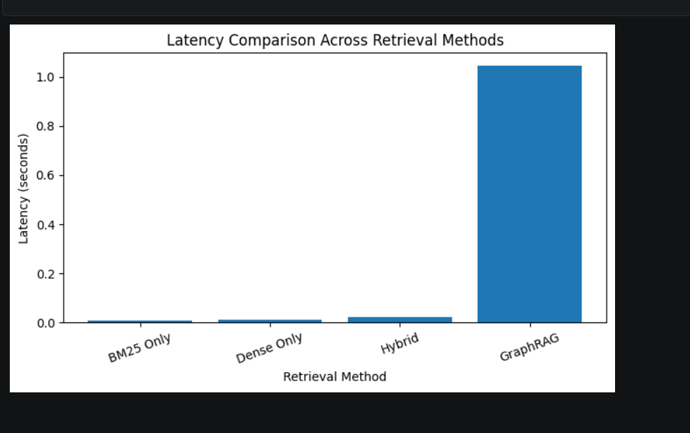
Figure 8 – Latency Comparison Across Retrieval Methods

10. Discussion
The results demonstrate that graph-guided retrieval improves evidence grounding and answer explainability compared with traditional retrieval methods.
Key observations include:
- Graph expansion identifies supporting evidence that may not be retrieved using vector search alone.
- Faithfulness remained high at 0.96.
- Citation-linked answers improve transparency.
- Provenance filtering improves trustworthiness.
- GraphRAG provides richer context despite slightly increased latency.
The main trade-off observed was the increase in retrieval latency caused by graph traversal and context expansion.

11. Conclusion
This deliverable successfully implemented a complete GraphRAG executor for the PDF-Papers AI Agent. The system integrates Neo4j graph retrieval, BM25 retrieval, dense semantic retrieval, hybrid fusion, answer generation with citations and page ranges, provenance-based safety filtering, and evaluation metrics.
The final system achieved:
- Average Answer Relevance: 0.73
- Average Faithfulness: 0.96
- p95 Latency: 0.9019 seconds
The GraphRAG architecture provides richer supporting evidence and stronger grounding than traditional retrieval approaches while maintaining practical response times. The implemented safety layer further improves trustworthiness by validating provenance and citation consistency.

References
Lewis, P. et al. Retrieval-Augmented Generation for Knowledge-Intensive NLP Tasks.
Neo4j Graph Database Documentation.
Sentence Transformers Documentation.
BM25 Ranking Function Documentation.
MongoDB Documentation.

